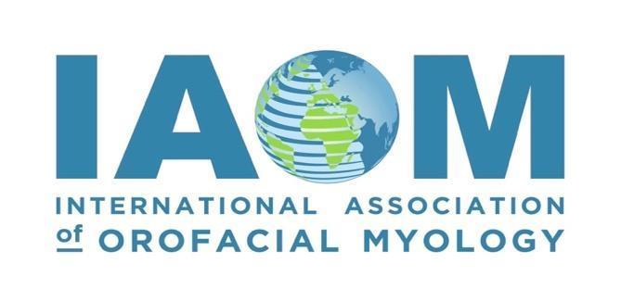

**Summit For Elevated Myofunctional Health: 2025 IAOM Convention**

**On-Demand/Video Recording Schedule of Presented Speakers**

Recordings will be available for access from October 13, 2025, through November 16, 2025, for

Professional Development Hours (PDH)

Each class is sold based off of the presentation time and hours as follows:

* 1 hour = $55.00
* 1.5 hours = $85.00
* 2.0 hours = $110.00
* 3.0 hours = $165.00

**Class 1: Linked through Pressure: Breathing, Posture and a Whole Lot More!** - ($110.00) **Mary Massery, PT, DPT, DSc**

2.0 Professional Development Hours (PDH)/.02 ASHA CEU

**Class 2:** **Building Authentic Relationships: Navigating Business, Clients, and Growth** - ($55.00)  
 **Brittni Winslow, OT**

1.0 Professional Development Hours (PDH)/.01 ASHA CEU

**Class 3: Uniting Airway Dentistry and Myofunctional Therapy for Optimal Patient Care** - ($85.00)  
 **Dr. Kevin Goles, DDS**

1.5 Professional Development Hours (PDH)/.15 ASHA CEU

**Class 4: Putting the FUN in Myofunctional Therapy** - ($85.00)  
 **Kimberly White, MS, CCC-SLP, COM®**

1.5 Professional Development Hours (PDH)/.15 ASHA CEU

**Class 5: Jaw Dropping Insights: Myofunctional Therapy and TMD** - ($85.00)  
 **Angie Lehman, RDH, COM®**

1.5 Professional Development Hours (PDH)/.15 ASHA CEU

**Class 6: Tongue-Tie Update: How Oral Restrictions Impact Feeding, Speech, Sleep, and More** – ($165.00) **Dr. Richard Baxter, DMD, MS, FAAPD** 3.0 Professional Development Hours (PDH)/.3 ASHA CEU

**Class 7:** **The Missing Link in Malocclusion: A Holistic Approach with Orofacial Myofunctional Therapy**

**for Lifelong Health –** ($55.00)  
**Dr. Kazuki Sekiguchi, DDS**

1.0Professional Development Hours (PDH) /.1 ASHA CEU

**Class 8: Two Nations, One Goal: Advancing Tongue-Tie Outcomes Through International and   
 Multidisciplinary Research and Care between Pediatric Dentistry and Speech-Language Pathology**

**-** ($85.00) **Dr. Ray Tseng, DDS, PhD & Dr. Sharon Smart, SLP,** **PhD**

1.5 Professional Development Hours (PDH)/.15 ASHA CEU

**Class 9: From tongue to posture, the hidden connections –** ($85.00) **Dr. Stefano Colasanto, DDS, DO**

1.5 Professional Development Hours (PDH)/.15 ASHA CEU

**Class 10: The airway team to breathe, sleep and dream –** ($110.00)

**Dr. David McIntosh, ENT Surgeon**

2.0 Professional Development Hours (PDH)/.2 ASHA CEU

**Class 11: Up-lock Breathing Training Oral Valves in the Dental Practice –** ($85.00) **Dr. Sandra Kahn, DDS, MDS**

1.5 Professional Development Hours (PDH)/.15 ASHA CEU

**Class 12: Team Up with the IAOM to Build a Clinical Database –** ($55.00) **Seema Virji, RDH, COM® and Dr. Nancy Solomon, PhD, CCC-SLP**

0.75 Professional Development Hours (PDH)/.05 ASHA CEU

ASHA Satisfactory Statement: To receive the certificate of completion, you must fully attend the selected course, request to be reported to ASHA CE Registry, and sign the intent to change statement at the completion of watching the recorded conference session.