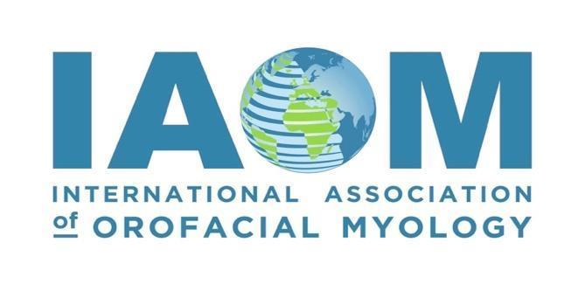

**Summit For Elevated Myofunctional Health: 2025 IAOM Convention**

**On-Demand/Video Recording Schedule of Presented Speakers**

Recordings will be available for access from October 13, 2025, through November 16, 2025, for

Professional Development Hours (PDH)

**Friday: September 26, 2025, Presenters**

**Class 1: Mary Massery, PT, DPT, DSc**

**Linked through Pressure: Breathing, Posture and a Whole Lot More!**

2.0 Professional Development Hours (PDH)

**Class 2: Brittni Winslow, OT**

**Building Authentic Relationships: Navigating Business, Clients, and Growth**

1.0 Professional Development Hours (PDH)

**Class 3: Dr. Kevin Goles, DDS**

Uniting Airway Dentistry and Myofunctional Therapy for Optimal Patient Care

1.5 Professional Development Hours (PDH)

**Class 4: Kimberly White, MS, CCC-SLP, COM®**

**Putting the FUN in Myofunctional Therapy**

1.5 Professional Development Hours (PDH)

**Class 5: Angie Lehman, RDH, COM®**

Jaw Dropping Insights: Myofunctional Therapy and TMD

1.5 Professional Development Hours (PDH)

Friday September 26, 2025, = Possible 7.5 IAOM Professional Development Hours

**Saturday: September 27, 2025, Presenters**

**Class 6 Part A: Dr. Richard Baxter, DMD, MS, FAAPD**

**Tongue-Tie Update: How Oral Restrictions Impact Feeding, Speech, Sleep, and More**

Must attend Parts A and B for 3.0 Professional Development Hours (PDH)

**Class 6 Part B: Dr. Richard Baxter, DMD, MS, FAAPD**

**Tongue-Tie Update : How Oral Restrictions Impact Feeding, Speech, Sleep, and More**

Must attend Parts A and B for 3.0 Professional Development Hours (PDH)

**Class 7:** **Dr. Kazuki Sekiguchi, DDS**

The Missing Link in Malocclusion: A Holistic Approach with Orofacial Myofunctional Therapy for

Lifelong Health

1.0 Professional Development Hours (PDH)

**Class 8: Dr. Ray Tseng, DDS, PhD & Dr. Sharon Smart, SLP,** **PhD**

**Two Nations, One Goal: Advancing Tongue-Tie Outcomes Through International and Multidisciplinary Research and Care between Pediatric Dentistry and Speech-Language Pathology**

1.5 Professional Development Hours (PDH)

**Class 9: Dr. Stefano Colasanto, DDS, DO**

**From tongue to posture, the hidden connections**

1.5 Professional Development Hours (PDH)

Saturday September 27, 2025 – Possible 7.0 IAOM Professional Development Hours (PDH)

**Sunday: September 28, 2025, Presenters**

**Class 10: Dr. David McIntosh, ENT Surgeon**

**​The airway team to breathe, sleep and dream**

2.0 Professional Development Hours (PDH)

**Class 11: Dr. Sandra Kahn, DDS, MDS**

**Up-lock Breathing Training Oral Valves in the Dental Practice**

1.5 Professional Development Hours (PDH)

**Class 12: Seema Virji, RDH, COM® and Dr. Nancy Solomon, PhD, CCC-SLP**

**Team Up with the IAOM to Build a Clinical Database**

0.75 Professional Development Hours (PDH)

Sunday September 28, 2025 – Possible 5.95 IAOM Professional Development Hours

Possible 18.50 IAOM and AGD Professional Development Hours, and 1.85 ASHA Professional Development Hours (PDH) for on-demand recording conference.

ASHA Satisfactory Statement: Fully attend the course, request to be reported to ASHA CE Registry, and sign the intent to change statement at the completion of watching the recorded conference.

