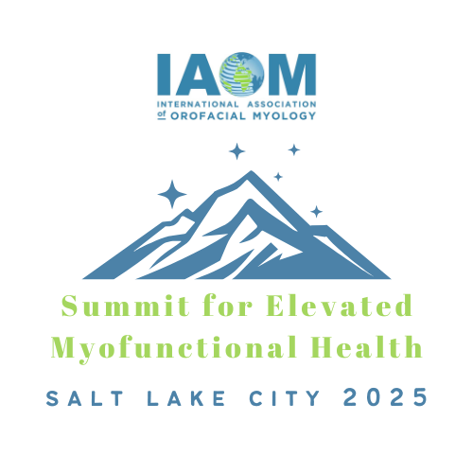

Hotels within walking Distance of the IAOM Annual Convention

IAOM Convention Site
Radison Downtown Salt Lake City
215 W S Temple St
Salt Lake City, UT 84101

- Le Méridien Salt Lake City Downtown (0.3 miles away)

131 South 300 West

Salt Lake City, UT 84101

Phone: 1 801-658-4400

Website

- Courtyard (Marriott) Salt Lake City Downtown (0.4 miles away)
345 West 100 South
Salt Lake City, UT 84101
Phone:1 385-290-6500
Website

- Hyatt Place Salt Lake City/Downtown/The Gateway (0.5 miles away)
55 North 400 West
Salt Lake City, UT 84101
Phone: 1 801-456-6300
Website

+18016584400
- Hyatt Regency (0.5 miles away)
170 South West Temple
Salt Lake City, UT 84101
Phone: 1 801-596-1234
Website

- Kimpton IHG Property (0.6 miles away)

15 West 200 South

Salt Lake City, UT 84101

Phone: 1-800 546-7866

Website

